

**PROJECT REPORT**

**OOP+DBMS**

**GROUP MEMBERS:**

**NAILA SHAHEEN (FA24B1-CS-015)**

**ALIZA SHAKEL (FA24B1-CS-027)**

**YASHA AKMAL (FA24B1-CS-049)**

**AMINA MALIK (FA24B1-CS-051)**

**SUBMITTED TO:**

**SIR ADEEL KHALID**

**SECTION:**

**BCS-II(A)**

**Project Report:**

**Hospital Management System**

1. **Project Title:**

**Hospital Management System – Login Page with Oracle Database (OJDBC8) Connectivity**

1. **Objective:**

The aim of this project is to develop a graphical user interface (GUI)-based Hospital Management System login page using Java Swing and to connect it to an Oracle Database using the OJDBC8 driver. The project demonstrates how patient-related data, when inserted via the Eclipse environment, is automatically stored and visible in the Oracle Database. The focus is on secure login, intuitive GUI design, real-time database integration, and modular data management (patients, doctors, appointments, staff, and billing).

**3. Technologies Used:**

| **Component** | **Technology** |
| --- | --- |
| Programming Language | Java |
| GUI Framework | Java Swing |
| IDE | Eclipse IDE |
| Database | Oracle Database 11g/18c/19c XE |
| JDBC Driver | Oracle JDBC Thin Driver (OJDBC8) |
| Database Tool | Oracle SQL Developer (optional) |

**4. Features Implemented:**

**4.1 Login Page:**

* A simple login interface using Java Swing.
* Admin-based authentication (username: admin, password: admin).
* Input validation with error messages for incorrect credentials.

**4.2 Dashboard Navigation:**

* After successful login, the system opens a dashboard with navigation buttons:
  + Patients
  + Doctors
  + Appointments
  + Staff
  + Billing
  + Logout

**4.3 Data Entry Modules:**

Each section opens a new window for managing respective records. Forms collect data through text fields and save them directly to the Oracle database.

**4.4 Database Insertion:**

* Data entered in the GUI (e.g., Patient ID, Name, Age, etc.) is inserted into Oracle tables.
* JDBC connection with PreparedStatement ensures safe and structured SQL execution.
* After insertion, the data is instantly displayed in the GUI table (JTable).

**4.5 Real-Time Integration with Oracle:**

* Each entry made in Eclipse is stored in real-time in the Oracle database.
* Database table is updated dynamically.

**5. Oracle Database Configuration:**

**Connection String:**

String DB_URL = "jdbc:oracle:thin:@10.11.0.22:1521:XE";

String USER = "FA24CS049";

String PASS = "oracle";

**DBConnection Class:**

* Handles all Oracle database connectivity.
* Reusable static method for obtaining connection.
* Includes error handling for failed connections.

**Main Functionality:**

Connection conn = DriverManager.getConnection(DB_URL, USER, PASS);

PreparedStatement stmt = conn.prepareStatement(...);

stmt.executeUpdate()

**6. Table Design (Oracle):**

**Table: HOSPITAL$PATIENTS**

| Column Name | Data Type | Description |
| --- | --- | --- |
| PATIENT_ID# | VARCHAR | Unique patient identifier |
| NAME_ | VARCHAR | Patient's full name |
| AGE# | INTEGER | Age of patient |
| GENDER$ | VARCHAR | Gender (M/F) |
| CONTACT_NO | VARCHAR | Contact phone number |

*Note:* Quoted column names are used to support special characters and preserve case sensitivity.

**7. Testing & Validation:**

| Test Case | Scenario | Expected Output | Result |
| --- | --- | --- | --- |
| TC1 | Admin login (admin/admin) | Dashboard appears | Passed |
| TC2 | Invalid login credentials | Error message shown | Passed |
| TC3 | Insert complete patient record | Data added to DB & shown in table | Passed |
| TC4 | Leave form fields empty | Shows validation error | Passed |
| TC5 | Oracle server not reachable | Connection error message | Passed |

**CODE FOR CREATION OF TABLES :** 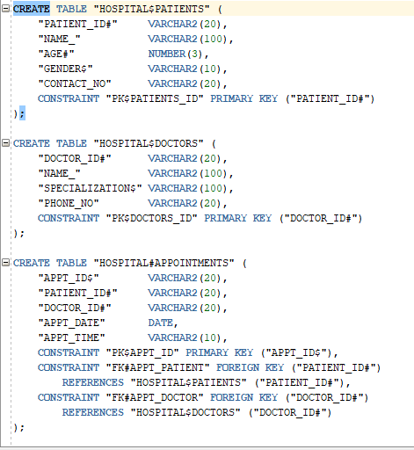

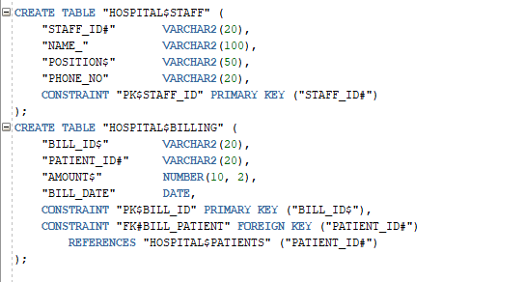

**ERD DIAGRAM:** 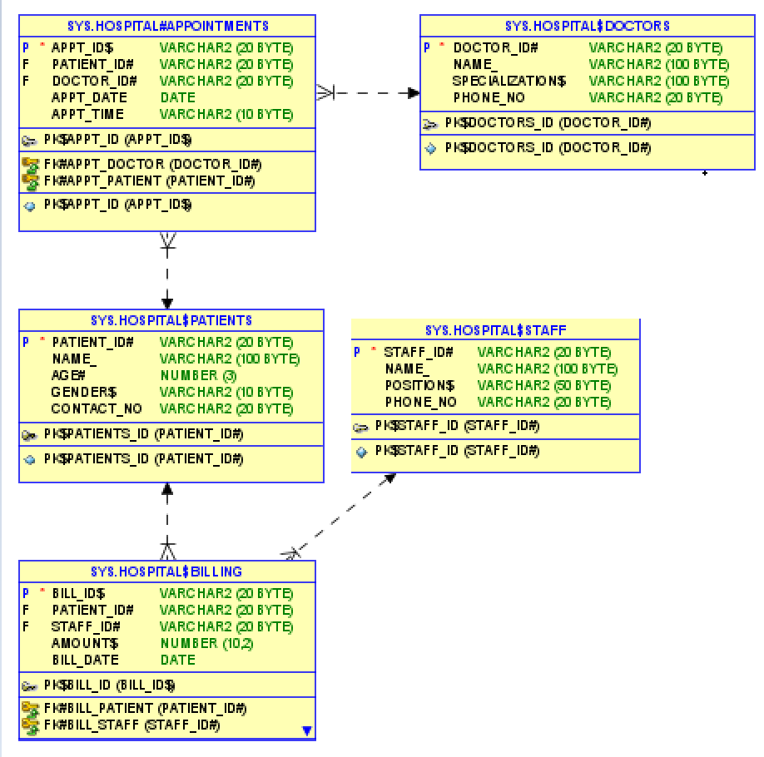

**8. Code And Output**

**Code for Login Page GUI :**

**package** hello;

**import** javax.swing.*;

**import** javax.swing.table.DefaultTableModel;

**import** java.awt.*;

**import** java.awt.event.*;

**import** java.sql.Connection;

**import** java.sql.PreparedStatement;

**public** **class** HospitalManagementSystem {

**public** **static** **void** main(String[] args) {

SwingUtilities.*invokeLater*(() -> **new** HospitalManagementSystem().showLoginWindow());

}

**void** showLoginWindow() {

JFrame loginFrame = **new** JFrame("Hospital Login");

loginFrame.setSize(400, 250);

loginFrame.setDefaultCloseOperation(JFrame.***EXIT_ON_CLOSE***);

loginFrame.setLayout(**null**);

loginFrame.getContentPane().setBackground(**new** Color(240, 248, 255));

JLabel title = **new** JLabel("Hospital Management System", JLabel.***CENTER***);

title.setFont(**new** Font("Times New Roman", Font.***BOLD***, 18));

title.setBounds(50, 20, 300, 30);

loginFrame.add(title);

JLabel userLabel = **new** JLabel("USERNAME:");

userLabel.setFont(**new** Font("Times New Roman", Font.***BOLD***, 12));

userLabel.setBounds(50, 70, 100, 25);

loginFrame.add(userLabel);

JTextField userField = **new** JTextField();

userField.setBounds(150, 70, 180, 25);

loginFrame.add(userField);

JLabel passLabel = **new** JLabel("PASSWORD:");

passLabel.setFont(**new** Font("Times New Roman", Font.***BOLD***, 12));

passLabel.setBounds(50, 110, 100, 25);

loginFrame.add(passLabel);

JPasswordField passField = **new** JPasswordField();

passField.setBounds(150, 110, 180, 25);

loginFrame.add(passField);

JButton loginBtn = **new** JButton("Login");

loginBtn.setBounds(150, 160, 100, 30);

loginBtn.setBackground(**new** Color(70, 130, 180));

loginBtn.setForeground(Color.***WHITE***);

loginBtn.setFocusPainted(**false**);

loginBtn.addActionListener(e -> {

String username = userField.getText().trim();

String password = **new** String(passField.getPassword()).trim();

**if** ("admin".equals(username) && "admin".equals(password)) {

loginFrame.dispose();

showDashboard();

} **else** {

JOptionPane.*showMessageDialog*(loginFrame, "Invalid username or password", "Error", JOptionPane.***ERROR_MESSAGE***);

}

});

loginFrame.add(loginBtn);

loginFrame.setLocationRelativeTo(**null**);

loginFrame.setVisible(**true**);

}

**void** showDashboard() {

JFrame frame = **new** JFrame("Hospital Management Dashboard");

frame.setSize(600, 450);

frame.setDefaultCloseOperation(JFrame.***EXIT_ON_CLOSE***);

frame.setLayout(**new** BorderLayout(10, 10));

frame.getContentPane().setBackground(**new** Color(240, 248, 255));

JLabel welcomeLabel = **new** JLabel("Welcome to Hospital Management System", JLabel.***CENTER***);

welcomeLabel.setFont(**new** Font("Arial", Font.***BOLD***, 22));

welcomeLabel.setBorder(BorderFactory.*createEmptyBorder*(20, 10, 20, 10));

frame.add(welcomeLabel, BorderLayout.***NORTH***);

JPanel buttonPanel = **new** JPanel(**new** GridLayout(3, 2, 20, 20));

buttonPanel.setBackground(**new** Color(240, 248, 255));

buttonPanel.setBorder(BorderFactory.*createEmptyBorder*(10, 40, 40, 40));

String[] btnNames = {"Patients", "Doctors", "Appointments", "Staff", "Billing", "Logout"};

**for** (String name : btnNames) {

JButton btn = **new** JButton(name);

btn.setFont(**new** Font("Arial", Font.***BOLD***, 18));

btn.setBackground(**new** Color(70, 130, 180));

btn.setForeground(Color.***WHITE***);

btn.setFocusPainted(**false**);

buttonPanel.add(btn);

btn.addActionListener(e -> {

**switch** (name) {

**case** "Patients": showPatientsWindow(); **break**;

**case** "Doctors": showDoctorsWindow(); **break**;

**case** "Appointments": showAppointmentsWindow(); **break**;

**case** "Staff": showStaffWindow(); **break**;

**case** "Billing": showBillingWindow(); **break**;

**case** "Logout": frame.dispose(); showLoginWindow(); **break**;

}

});

}

frame.add(buttonPanel, BorderLayout.***CENTER***);

frame.setLocationRelativeTo(**null**);

frame.setVisible(**true**);

}

JFrame createDataWindow(String title, String[] columns, String[] fieldLabels) {

JFrame frame = **new** JFrame(title);

frame.setSize(700, 450);

frame.setLayout(**new** BorderLayout(10, 10));

frame.getContentPane().setBackground(**new** Color(245, 245, 245));

frame.setLocationRelativeTo(**null**);

DefaultTableModel model = **new** DefaultTableModel(columns, 0);

JTable table = **new** JTable(model);

table.setFillsViewportHeight(**true**);

JScrollPane scrollPane = **new** JScrollPane(table);

frame.add(scrollPane, BorderLayout.***CENTER***);

JPanel formPanel = **new** JPanel(**new** GridLayout(fieldLabels.length + 1, 2, 10, 10));

formPanel.setBackground(**new** Color(245, 245, 245));

JTextField[] fields = **new** JTextField[fieldLabels.length];

**for** (**int** i = 0; i < fieldLabels.length; i++) {

formPanel.add(**new** JLabel(fieldLabels[i] + ":"));

JTextField field = **new** JTextField();

fields[i] = field;

formPanel.add(field);

}

JButton addBtn = **new** JButton("Add " + title.replace(" Management", ""));

addBtn.setBackground(**new** Color(70, 130, 180));

addBtn.setForeground(Color.***WHITE***);

addBtn.setFocusPainted(**false**);

formPanel.add(**new** JLabel());

formPanel.add(addBtn);

addBtn.addActionListener(e -> {

**try** {

String patientId = fields[0].getText().trim();

String name = fields[1].getText().trim();

String age = fields[2].getText().trim();

String gender = fields[3].getText().trim();

String contact = fields[4].getText().trim();

**if** (patientId.isEmpty() || name.isEmpty() || age.isEmpty() || gender.isEmpty() || contact.isEmpty()) {

JOptionPane.*showMessageDialog*(frame, "Please fill all fields", "Error", JOptionPane.***ERROR_MESSAGE***);

**return**;

}

// Connect and insert into Oracle DB

Connection conn = DBConnection.*connect*();

PreparedStatement stmt = conn.prepareStatement(

"INSERT INTO \"HOSPITAL$PATIENTS\" (\"PATIENT_ID#\", \"NAME_\", \"AGE#\", \"GENDER$\", \"CONTACT_NO\") VALUES (?, ?, ?, ?, ?)"

);

stmt.setString(1, patientId);

stmt.setString(2, name);

stmt.setInt(3, Integer.*parseInt*(age))

stmt.setString(4, gender);

stmt.setString(5, contact);

stmt.executeUpdate();

stmt.close();

conn.close();

// Update GUI table

model.addRow(**new** Object[]{patientId, name, age, gender, contact});

**for** (JTextField f : fields) f.setText("");

JOptionPane.*showMessageDialog*(frame, "Patient added successfully to database.");

} **catch** (Exception ex) {

ex.printStackTrace();

JOptionPane.*showMessageDialog*(frame, "Error adding patient: " + ex.getMessage(), "Error", JOptionPane.***ERROR_MESSAGE***);

}

});

frame.add(formPanel, BorderLayout.***NORTH***);

**return** frame;

}

**void** showPatientsWindow() {

String[] columns = {"Patient ID", "Name", "Age", "Gender", "Contact"};

String[] fields = {"Patient ID", "Name", "Age", "Gender", "Contact"};

JFrame frame = createDataWindow("Patients Management", columns, fields);

frame.setVisible(**true**);

}

**void** showDoctorsWindow() {

String[] columns = {"Doctor ID", "Name", "Specialization", "Phone"};

String[] fields = {"Doctor ID", "Name", "Specialization", "Phone"};

JFrame frame = createDataWindow("Doctors Management", columns, fields);

frame.setVisible(**true**);

}

**void** showAppointmentsWindow() {

String[] columns = {"Appointment ID", "Patient ID", "Doctor ID", "Date", "Time"};

String[] fields = {"Appointment ID", "Patient ID", "Doctor ID", "Date (YYYY-MM-DD)", "Time (HH:MM)"};

JFrame frame = createDataWindow("Appointments Management", columns, fields);

frame.setVisible(**true**);

}

**void** showStaffWindow() {

String[] columns = {"Staff ID", "Name", "Position", "Phone"};

String[] fields = {"Staff ID", "Name", "Position", "Phone"};

JFrame frame = createDataWindow("Staff Management", columns, fields);

frame.setVisible(**true**);

}

**void** showBillingWindow() {

String[] columns = {"Bill ID", "Patient ID", "Amount", "Date"};

String[] fields = {"Bill ID", "Patient ID", "Amount", "Date (YYYY-MM-DD)"};

JFrame frame = createDataWindow("Billing Management", columns, fields);

frame.setVisible(**true**);

}

}

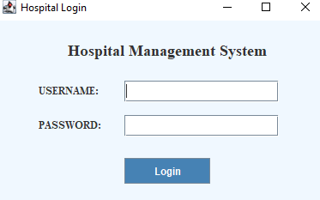

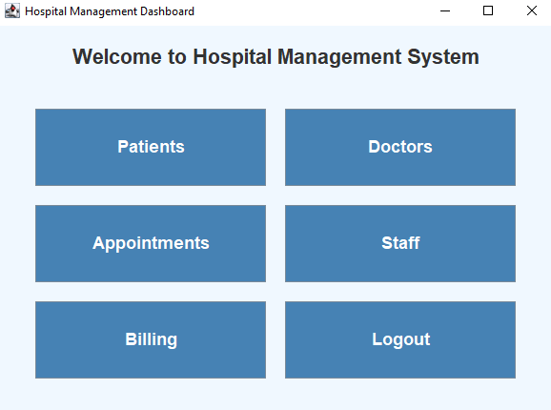

**CODE FOR CONNECTION:**

**package** hello;

**import** java.sql.Connection;

**import** java.sql.DriverManager;

**import** java.sql.SQLException;

**public** **class** DBConnection {

**public** **static** Connection connect() {

Connection conn = **null**;

String DB_URL = "jdbc:oracle:thin:@10.11.0.43:1521:XE";

String USER = "FA24CS049";

String PASS = "oracle";

**try** {

conn = DriverManager.*getConnection*(DB_URL, USER, PASS);

System.***out***.println("Connected to the Oracle DB!");

} **catch** (SQLException e) {

System.***err***.format("SQL State: %s\n%s", e.getSQLState(), e.getMessage());

} **catch** (Exception e) {

e.printStackTrace();

}

**return** conn;}

**public** **static** **void** main(String[] args) {

Connection conn = *connect*();

**if** (conn != **null**) {

System.***out***.println("Connection test successful!");

} **else** {

System.***out***.println("Connection test failed.");

}

}

}

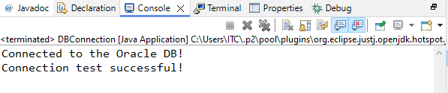

**9. Conclusion:**

This project demonstrates the practical implementation of database connectivity in a Java Swing application. The login system, dashboard navigation, and patient module show effective integration with Oracle via JDBC. Data is safely transmitted and stored in the Oracle database using the OJDBC8 driver. The GUI is responsive and user-friendly, making it a suitable base for future expansion.

**10. Future Enhancements:**

* Enable role-based authentication (e.g., doctor, admin, receptionist).
* Add update and delete operations.
* Load records dynamically from database during window initialization.
* Encrypt stored passwords.
* Improve form validations with regular expressions.
* Generate reports in Excel or PDF format.

**11. References:**

* Oracle Documentation: <https://docs.oracle.com>
* Java Swing Tutorial: <https://docs.oracle.com/javase/tutorial/uiswing/>
* OJDBC8 Driver Setup: <https://www.oracle.com/database/technologies/appdev/jdbc-downloads.html>

***THANK YOU***